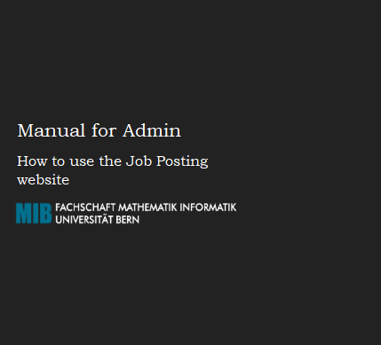

Оглавление

Introduction 3

Definitions 3

Admin’s rights and opportunities and responsibilities 3

Log-in 4

General information 5

Users Approval and Disapproval 7

Job Postings Approval and Disapproval 9

Featuring and unfeaturing 11

# **Introduction**

Hello! This instruction has been compiled to clarify administrator rights and opportunities, as well as to simplify the use of the website.

## Definitions

**User** are companies which create Job Postings on the website.

**Guests** are Students who are looking for some appropriate Jobs.

## Admin’s rights and opportunities and responsibilities

All the users which register on the website should be approved by Admin. The Admin’s responsibility is to check new users’ information and approve their application or deny it if the information provided does not comply with accepted standards. In case of denial the Admin should write the reason of rejection in the special field.

Users can change their information. In this case their status will be automatically changed to “Unverified” and the Admin should check the information again.

All the users can post their Job Postings on the website. After they fill in the needed information, the Job Posting has “Unaccepted” status and also should be approved or disapproved by Admin.

Moreover, Admin has an ability to Feature and Unfeature users and Job Postings. All the featured users will have blue star near their names. All the featured Job Postings will be shown on the top of the list of Job Postings and also have blue star near the title.

To use this manual, you should have a registration email and password as an Admin.

# **Log-in**

First opening the website you are led to the main page. In order to log in as an administrator, firstly, click the blue “Sign In” button in the upper right corner.

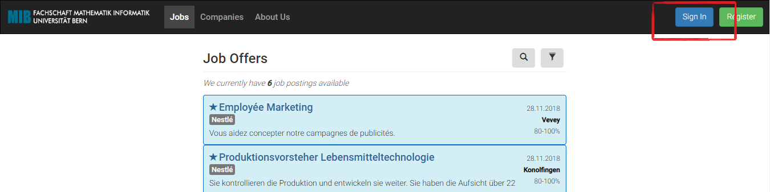

After that, fill in the E-mail and Password fields with the data you were given by the owner and click the blue “Sign In” button which is under these fields.

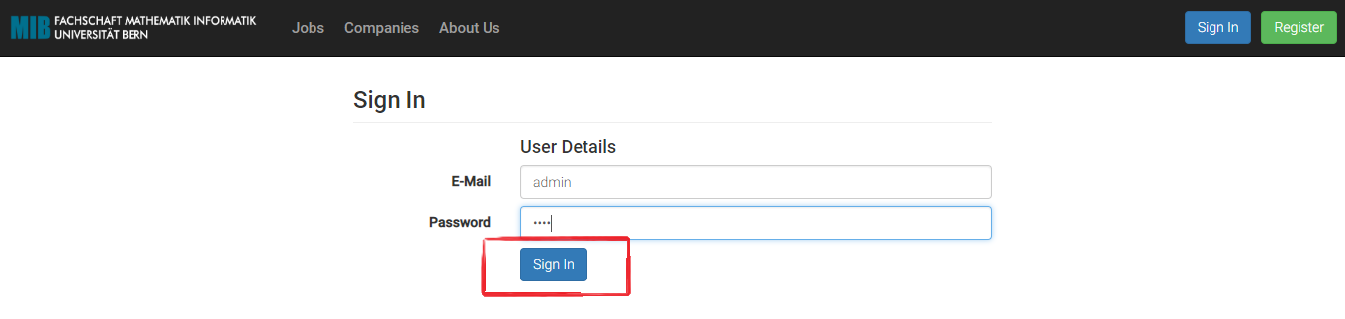

If both E-mail and Password are correct you will be led to the main page.

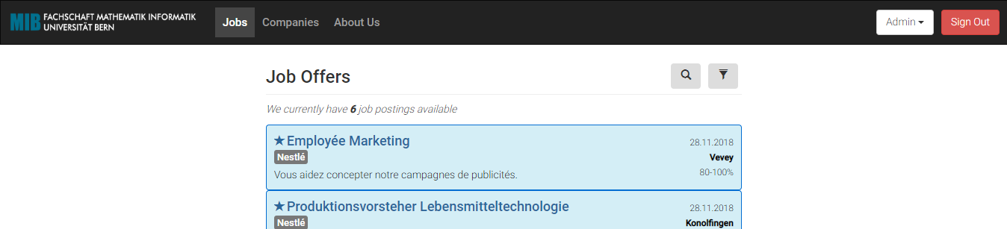

# **General information**

To open all the Admin special pages, click the white “Admin” button in the upper right corner.

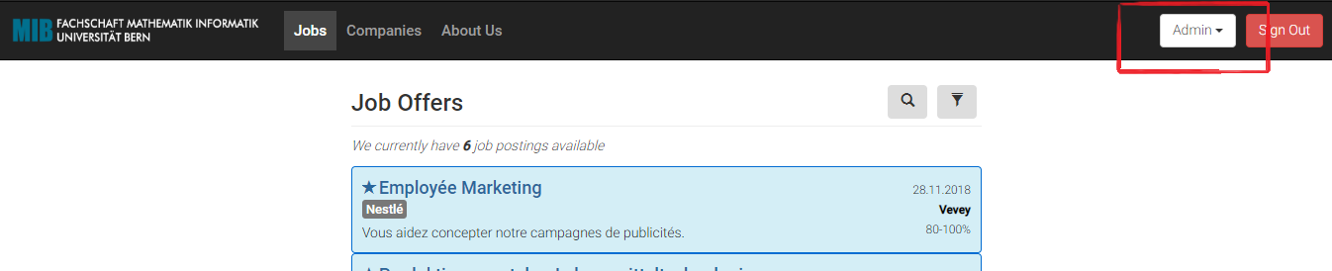

In “SHOW ALL” part the Admin can see all existing Companies or Job Posting with their statuses. Clicking “SHOW IN REVIEW” buttons, the Admin can see all the Companies/Job Postings which should be checked.

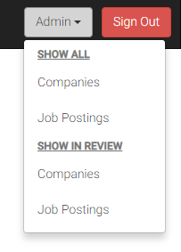

On “All Companies” page you can see all the users which exist in the system with their statuses “Verified” and “In Verification”. Also, on this page you can delete users or make them unverified. By special button you are able to make the user featured and unfeatured.

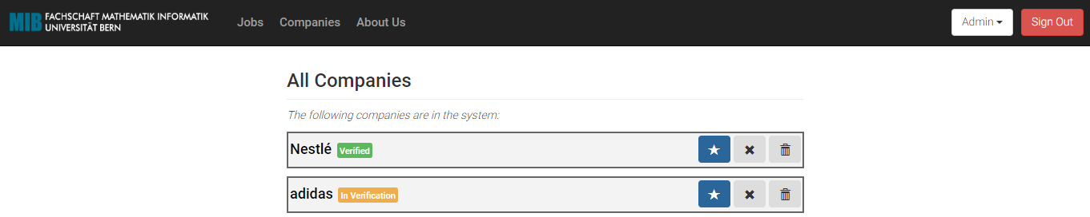

On “All Jobs” page you can see all the Job Postings which exist in the system with their statuses “Approved”, “Denied” and “In Review”. On this page you can approve, deny and delete Job Postings. Moreover, on this page you can make Job Postings featured and Unfeatured.

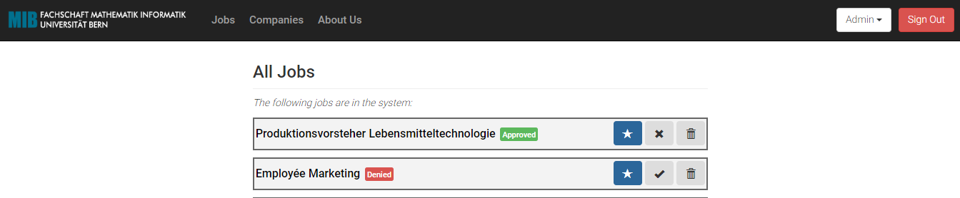

The page “Unverified Companies” is constructed to make you able to see all the users that need to be checked.

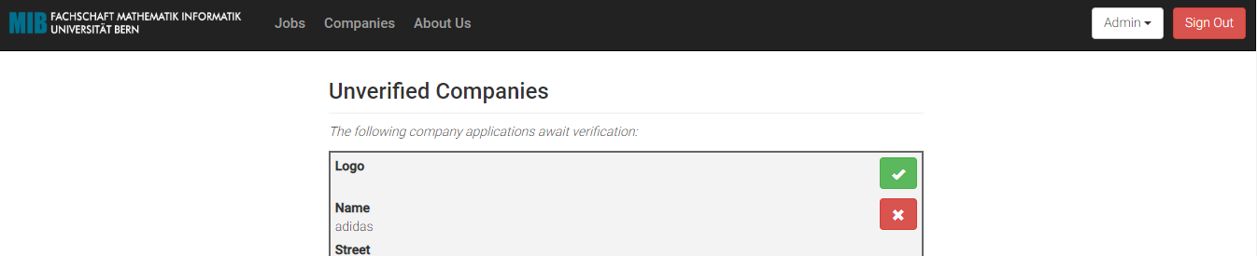

The page “Unaccepted Jobs” exists for work with Job Postings in review.

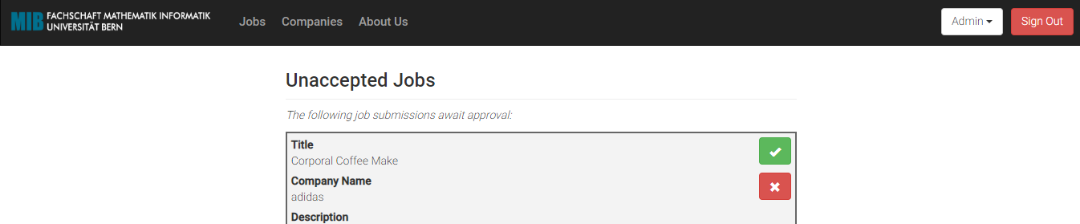

# **Users Approval and Disapproval**

One of the Admin’s responsibilities is to approve new users’ registrations and data changes of the already existing users.

In order to check if there are any users whose new registration or data changes require approval click the white “Admin” button in the upper right corner.



To work with users, click “Companies” in the second part.

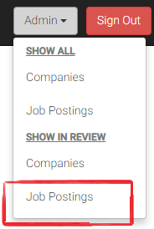

You will be led to the page with unverified companies. Here you can read the information about it.

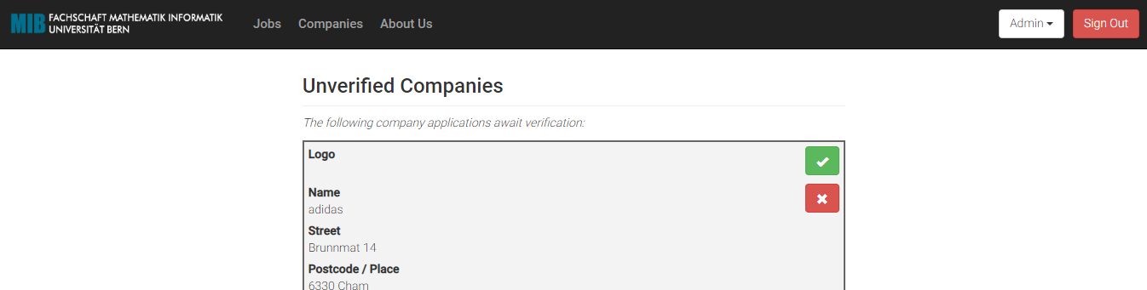

To approve the user, you should press the green button.

In case of denial, you should also provide a reason in the special field which will appear automatically:

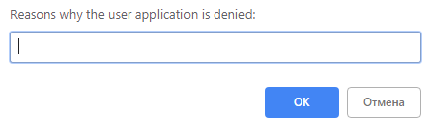

You also can deny the user on the page “All Companies”

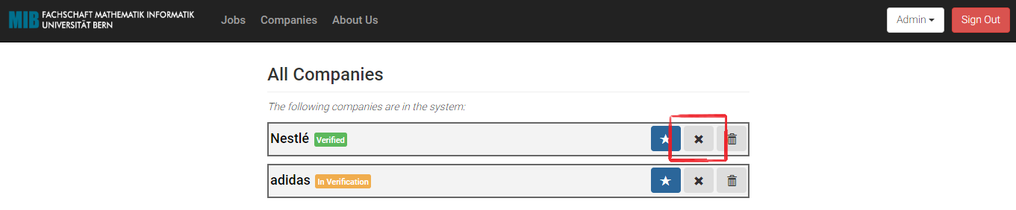

# **Job Postings Approval and Disapproval**

Another Admin’s responsibility is to approve new or changed Job Postings.

In order to check if there are any Job Postings in review click the white “Admin” button in the upper right corner.



To work with Job Postings, click “Job Postings” in the second part.

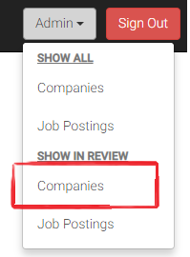

You will be led to the page with Unaccepted Jobs. Here you can read the information about it.

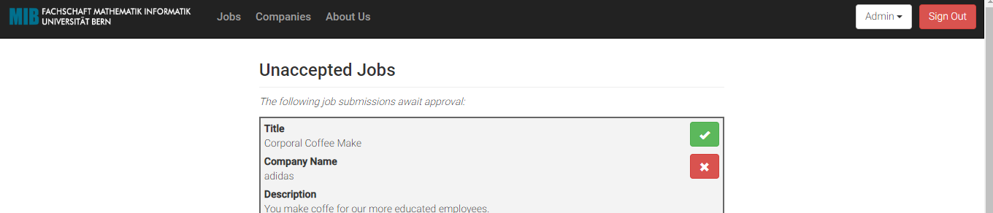

To accept the job, you should press the green button.

In case of denial, you should click the red button. You also should provide a reason in the special field which will appear automatically:

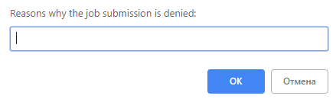

You can accept and deny Job Postings on the “All Jobs” page

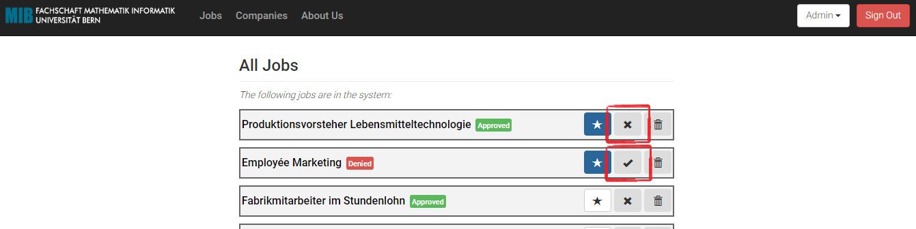

# **Featuring and unfeaturing**

To feature/unfeatured a user you should press “Admin” button and choose “Companies” in the “SHOW ALL” part. If the feature button is blue – the user is featured.

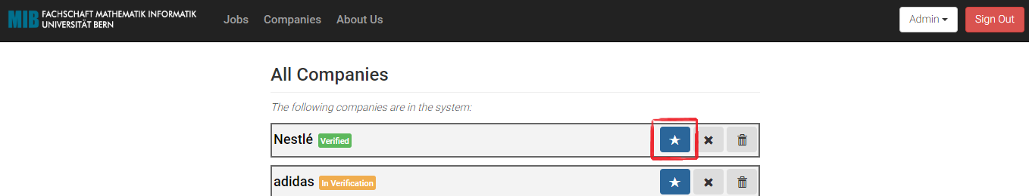

To feature/unfeatured a Job Posting you should press “Admin” button and choose “Job Postings” in the “SHOW ALL” part. If the feature button is blue – the Job Posting is featured.

